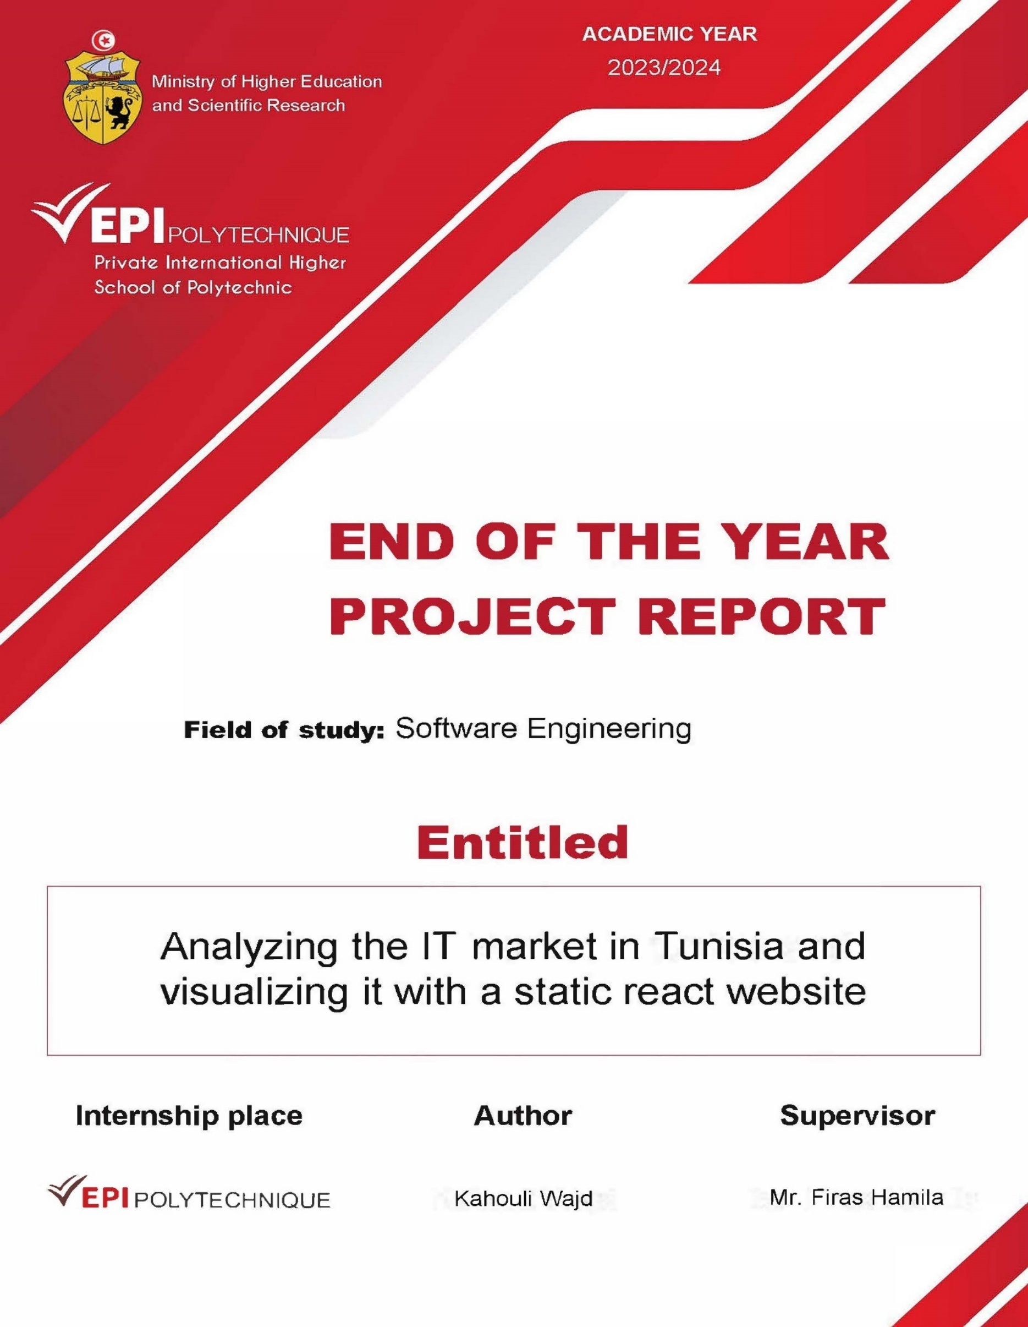

# 

**Abstract**

This report represents the end of the year project for the second year of the computer science engineering discipline within the International Multidisciplinary School Polytech of Sousse for the academic year 2023/24

#### This project aims to collect, clean, analyze, and visualize data from various job listing websites to gain insights into the IT job market. By using web scraping and data manipulation techniques using Python. The results are presented on a static React website, offering an accessible and interactive platform for users to explore the findings.

#### 

#### 

#### 

#### 

#### 

**Table of Context**

General Introduction 1

Chapter 1: Preliminary study and requirements specification 3

Introduction 3

1. Project Presentation 3

2. Study & critique of the existing state 3

3. Proposed Solution 7

4. Requirements specifications 7

4.1. Functional Requirements 7

4.2. Non-Functional requirements 8

5. Working Methodology 8

Conclusion 9

Chapter 2: Data Analysis 10

Introduction 10

1. Defining Objectives 10

2. Collecting Data 12

2.1. TunisieTravail 12

2.2. Tanitjobs 14

2.3. Keejob 16

2.4. Paylab 18

3. Data Extraction 20

3.1. Legal measurements 20

3.2. Data fetching 21

4. Cleaning & Filtering Data 23

5. Data Analysis 24

5.1. IT jobs market share 24

5.2. IT Jobs locations 25

5.3. IT Domains in demand 26

5.4. IT Technologies in demand 29

5.5. IT Salaries 30

Conclusion 31

Chapter 3: Realization and Implementation 32

Introduction 32

1. Technologies used 32

2. Website implementation 36

Conclusion 38

General Conclusion 39

Netography 40

**List of Figures**

Figure 1: Distribution of job ads across digital skills categories 4

Figure 2: Geographic locations of online jobs ads 5

Figure 3: List of IT jobs categorized by specialty in the Himalayas platform 6

Figure 4: Waterfall model representation 9

Figure 5: Flowchart Workflow Diagram 11

Figure 6: TunisieTravail logo 12

Figure 7: TunisieTravail jobs listing structure 13

Figure 8: Tanitjobs logo 14

Figure 9: Tanitjobs jobs listing structure 15

Figure 10: Keejob logo 16

Figure 11: Keejob jobs listing structure 17

Figure 12: Paylab logo 18

Figure 13: Paylab salaries data 19

Figure 14: Robots file for each website 20

Figure 15: Creating a web scraper for each source based on their structure 21

Figure 16: Output sample of the data fetching process 22

Figure 17: Keywords dictionaries 23

Figure 18: Output sample of filtering data to IT related data 24

Figure 19: IT jobs growth in the job market represented by a line chart 25

Figure 20: IT jobs locations in Tunisia represented by a horizontal bar chart 26

Figure 21: IT Domains distribution represented by a doughnut chart 27

Figure 22: Trending technologies in the IT job market 29

Figure 23: IT Salaries in the IT job market 30

Figure 24: Python logo 32

Figure 25: React logo 34

Figure 26: Github Desktop logo 35

Figure 27: Visual Studio Code logo 36

Figure 28: Dashboard 1 36

Figure 29: Dashboard 2 37

Figure 30: Real-time interactive chart 37

Figure 31: System flowchart 38

**List of Tables**

Table 1: The percentage of each IT domain in the IT job market 27

Table 2: Percentage of each technology in the IT market 29

**List of abbreviations**

* IT : Information Technology

# General Introduction

In the rapidly evolving job market, staying informed about employment trends, technology demands, and the geographical distribution of job opportunities is crucial for students, job seekers, employers, and policy makers alike. The advent of digital platforms has significantly transformed how job offers are posted, searched, and analyzed. Leveraging these digital resources to derive meaningful insights requires a structured and methodical approach.

This project aims to harness the power of data analytics to provide a comprehensive overview of the current job market landscape. By systematically collecting, cleaning, analyzing, and visualizing job offer data from multiple online sources, we can uncover valuable trends and patterns. The insights gained from this analysis will be presented through an interactive dashboard, offering users an intuitive way to explore and understand the dynamics of the job market.

The project is structured into three distinct chapter:

1. Chapter 1: Preliminary study and requirements specification
   * This initial phase focuses on gathering job offer data from various websites, ensuring a diverse and comprehensive dataset. The data is meticulously cleaned and structured, addressing issues such as missing values and duplicate entries to ensure its integrity and reliability.
2. Chapter 2: Data Analysis
   * In the second chapter, Indicates the process of collecting and cleaning data which is later filtered and analyzed in order to identify key trends and patterns. This involves setting specific research objectives, manipulating and organizing the data, and categorizing the results to form logical and meaningful insights.
3. Chapter 3: Realization and Implementation
   * The third phase emphasizes the visualization of the analyzed data. Coherent and up-to-date charts are created to represent the findings, making complex data easily understandable. Implementing these chart components in a react based platform will allow users to explore the data through a user-friendly interface.

By following this structured approach, the project not only aims to provide a snapshot of the current job market but also to create a tool that can be continually updated and used for ongoing analysis. The insights derived from this project have the potential to inform job seekers, students, guide employers in their recruitment strategies, and assist policy makers in understanding employment trends.

# Chapter 1: Preliminary study and requirements specification

## Introduction

This chapter sets the stage for our project. Through a preliminary study, we analyze existing job market tools and their shortcomings. This analysis guides our innovative solution: a data-driven platform providing a comprehensive picture of the job market. Next, we define the stakeholders involved and the functionalities the platform will offer. Additionally, we establish performance, security, and usability expectations. Finally, we outline the project's methodology, detailing data collection, analysis, and development phases.

## Project Presentation

Having a clear vision of the job market seems to be a very challenging task. And there have been multiple attempts to overcome this problem. The two typical solutions seem to be either doing a classic data analysis report to describe the market at a certain period or having a platform to display the current active jobs which could be used to have a surface-level idea about the state of the market. Therefore, we’ll be taking samples of each solution to discuss and analyze it.

## Study & critique of the existing state

An interesting data analysis report on the IT market in Tunisia was published by Digital Talent titled “Mapping the demand for digital skills in Tunisia”

**About the report**

This white paper series is part of an accompanying research project implemented by Einstein Center Digital Future (ECDF), funded by the Federal Ministry of Economic Cooperation and Development (BMZ), and commissioned to the Deutsche Gesellschaft für Internationale Zusammenarbeit (GIZ) GmbH, as part of the Special Initiative on Training and Job Creation – “Invest for Jobs” through the GIZ flagship program the Digital Transformation Center Tunisia. The Digital Transformation Center Tunisia aims to support a variety of Tunisia’s current digital priorities, from assisting Tunisian startups and facilitating the transformation of Tunisia’s industrial companies towards Industry 4.0 to operationalizing the Tunisian digital transformation strategies for all relevant stakeholders, including rural communities and civil society.

We collected data from the largest Tunisian online job platform through web crawling between May 2020 and May 2021, obtaining a sample of 59,254 online job ads which included 24,718 digital skill-based jobs. – [1]

**Highlights of the report**

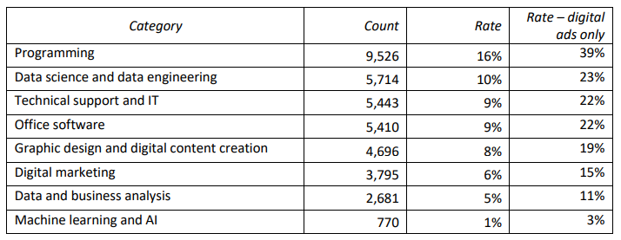

Figure 1: Distribution of job ads across digital skills categories

The distribution of jobs across the digital skills table represents some valuable data that could even be used to compare the results of our proper projects. Thus, better understanding how certain domains are evolving from 2020 to 2024. Also identifying which categories are in a stagnant state.

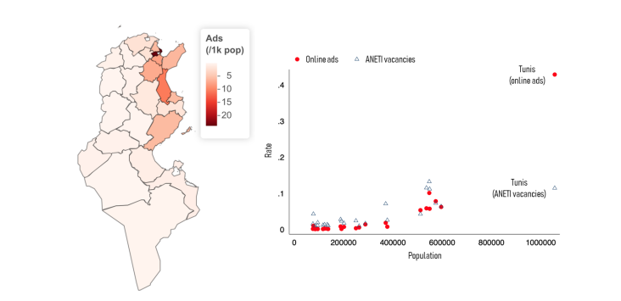

Figure 2: Geographic locations of online jobs ads

There seems to be an obvious pattern for the geographical locations that offer the most IT related jobs. With the capital Tunis having the highest rate. Followed by other governorates in the Sahel area such as Sousse and Sfax.

**Keynotes**

* While the report offers valuable insights, the analysis is limited by the time frame (May 2020 - May 2021). Technologies evolve at a very high pace which means this report may turn obsolete very quickly.
* Although the data collected is quite important in size, it is withdrawn from one singular source. Which could possibly deviate the project in a narrow direction

While the report offers valuable insights, it's important to acknowledge limitations. The data timeframe may not reflect current trends, and relying on a single source limits the overall picture. Future research could benefit from a broader timeframe and include data from diverse platforms. Expanding the scope would provide a more comprehensive understanding of Tunisia's digital skills landscape, informing effective policy and educational interventions for a future-proof workforce.

On the other hand, we do found platforms that try to constantly provide stay up-to-date information about the IT job market such as Himalayas

**About the platform**

Today’s companies are global from day one, customers are spread across the globe, so why aren’t employees? As Stripe said, “We feel closer to customers because we literally are”.

This is why we decided to start Himalayas. We want to re-envision a new, more enjoyable standard for hiring for and finding remote jobs. We couldn’t find a remote job board we loved, so we’re building one. Here’s how we’re going to go about it:

* Deliver a great UX, focused on speed and efficiency: The average job board looks like it hasn’t been updated in a decade. Our goal is to make the experience frictionless, simple, and fast.
* Connect to companies, not recruiters: Speak directly to founders and hiring managers. No third-party recruiters are allowed.
* Building for the long-term: We want Himalayas to be measured in decades, not days. We’re focused on serving two populations: job seekers and hirers. That’s it. - [2]

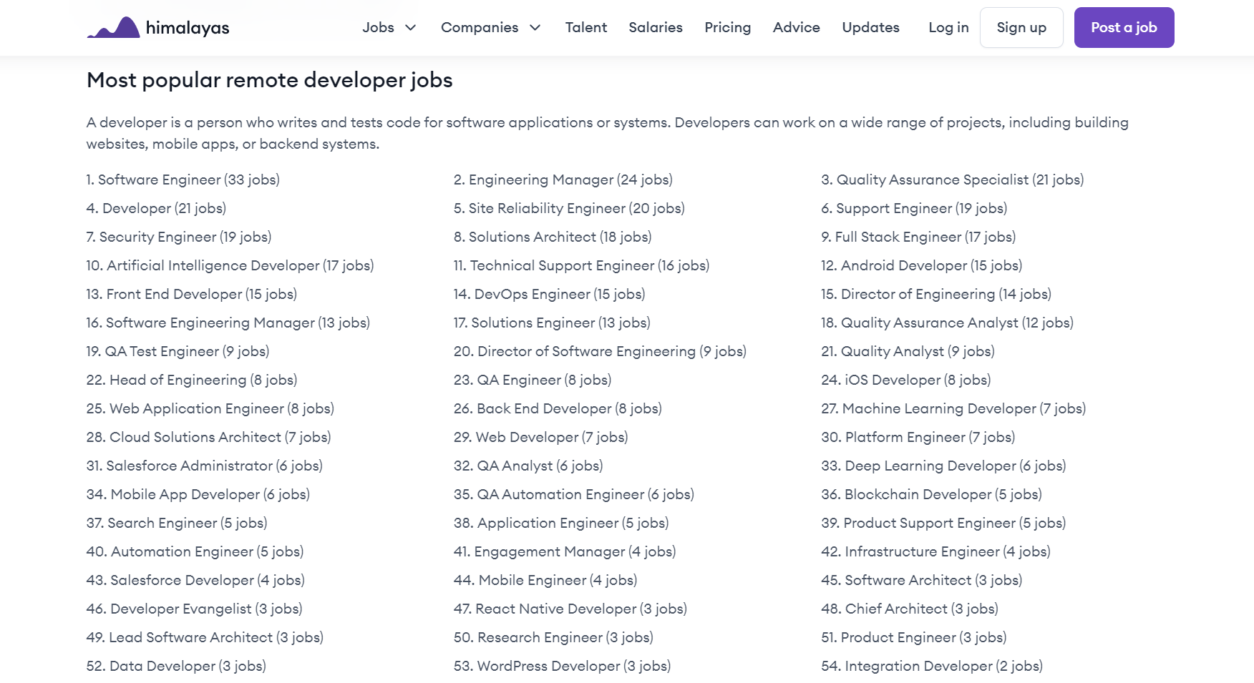

Figure 3: List of IT jobs categorized by specialty in the Himalayas platform

**Keynotes**

* The platform provides information about jobs from different domains related to technology. However, most of these jobs are remote jobs only. Furthermore, various offers are not located within Tunisia.
* The platform indicates the number of jobs in each specialty. However, It does not provide any analytical insights or charts to visualize this data.

While the Himalayas currently focuses on remote technology jobs and doesn't showcase the geographical distribution of these opportunities, its strength lies in its dedication to long-term impact. The platform caters to both job seekers and companies, aiming to build a thriving remote work ecosystem. Nevertheless, future iterations could benefit from incorporating data visualizations and insights to further empower users with a richer understanding of available careers across different specializations.

## Proposed Solution

The breakthrough for this problem relies on extending and transforming the classic research way of analyzing data and turning it into a modern up-to-date platform which won’t be limited to a specific period. A Platform that will visualize data using multiple modern charts.

## Requirements specifications

This section outlines the necessary requirements for the system to function effectively. It covers both the functional requirements, detailing specific behaviors and tasks the system must perform, and non-functional requirements, describing the system's performance, reliability, and security characteristics. These specifications ensure the system meets user needs and operates efficiently.

### Functional Requirements

Functional requirements define the specific behavior or functions of the system. They describe what the system should do, including tasks, data processing, and interactions.

**Data Collection**

* Web Scraping: The system shall scrape job listings from specified websites, including details such as job title, description, location, company, and posted date.

**Data Cleaning**

* Duplicate Removal: The system shall identify and remove duplicate job listings.
* Missing Data Handling: The system shall handle missing data by either filling in default values or excluding incomplete entries.

**Data Visualization**

* Charts and Graphs: The system shall generate various charts (e.g., bar charts, pie charts) to visually represent the analysis results.
* Interactive Dashboard: The system shall provide an interactive dashboard to display the visualizations and allow users to filter and explore the data

### Non-Functional requirements

**Performance**

* Scalability: The system shall be able to scale and handle increased loads, including more job listings.
* Response Time: The system shall provide the dashboard charts within a few seconds.

**Usability**

* User-Friendly Interface: The system shall have an intuitive and easy-to-use interface.

## Working Methodology

Since each step in our projects depends on the previous step to it. Each stage must be completed successfully before moving on to the next. This traditional method follows a linear, sequential process which is how our project is supposed to be executed. It might be a smart choice to use the **waterfall** methodology.

The waterfall model is a breakdown of development activities into linear sequential phases, meaning they are passed down onto each other, where each phase depends on the deliverables of the previous one and corresponds to a specialization of tasks. This approach is typical for certain areas of engineering design.

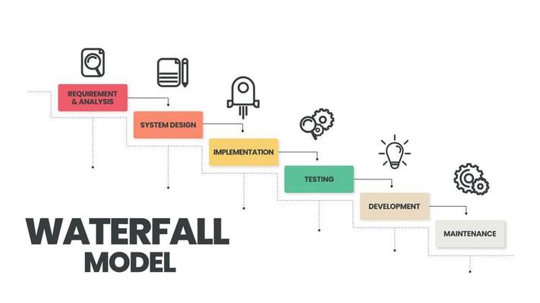

Figure 4: Waterfall model representation

**Benefits**

* Structured and predictable approach.
* Clear documentation throughout the project lifecycle.

## Conclusion

In this chapter, we have laid the foundational framework for our project by providing an in-depth overview of the project's objectives and scope. We presented a comprehensive study and critique of the existing state, highlighting current limitations and gaps. Based on this analysis, we proposed a robust solution tailored to address these gaps effectively. We also delineated the functional and non-functional requirements essential for the system's optimal performance. Finally, we outlined the working methodology that will guide the development process, ensuring a structured and systematic approach. This preliminary study sets the stage for the subsequent phases, where these plans and requirements will be translated into actionable steps and tangible results.

# Chapter 2: Data Analysis

## Introduction

In the following chapter, we delve into the intricacies of data analysis, a critical component that drives the insights and conclusions of our project. This chapter will guide you through the meticulous process of defining objectives, collecting relevant data, cleaning and filtering it for accuracy, and performing comprehensive analyses. By thoroughly examining the data, we aim to uncover valuable trends and patterns within the IT job market, providing meaningful insights that will inform career decisions and strategic planning. This systematic approach ensures that our analysis is both robust and reliable, setting the stage for informed decision-making based on data-driven evidence.

## Defining Objectives

Defining the objectives is a crucial step in the project, serving as the foundation upon which all subsequent work is built. Clear and precise objectives not only guide the direction of our analysis but also ensure that our efforts are aligned with the intended outcomes.

To achieve meaningful results, it is essential to ask the right questions. For individuals and professionals in the IT field, understanding the dynamics of the job market is vital. One of the most frequently asked questions is: which technology is most in demand? This knowledge can significantly influence career choices and professional development.

**Key objectives of this project include**

* **Job Technologies:** Identifying the technologies that are most sought after by employers. This helps job seekers focus on acquiring relevant skills and expertise.
* **Job Locations:** Analyzing the geographical distribution of IT jobs to understand which regions offer the most opportunities.
* **Jobs per Domain:** Categorizing jobs by domain (e.g., web development, data science, cybersecurity) to provide a clearer picture of demand in specific areas.
* **Job Salaries:** Examining salary data to understand compensation trends across different roles and regions.
* **Job Posting Frequency:** Determining how many jobs are posted each day, which can indicate the demand and growth of the job market.
* **Years of Experience:** Analyzing the required experience levels (junior, mid-level, senior) for different job roles to help professionals understand their standing in the job market.

**Description for Workflow Chart**

This workflow chart outlines the comprehensive process of data analysis, starting from data collection, through cleaning and filtering, analyzing, and finally visualizing the data. The initial phase involves sourcing data from multiple websites, followed by meticulous data cleaning to ensure accuracy. The analysis phase focuses on deriving meaningful insights and statistical calculations, which are then visualized through various chart types to present the findings effectively. This structured approach ensures a thorough and systematic analysis of job market trends.

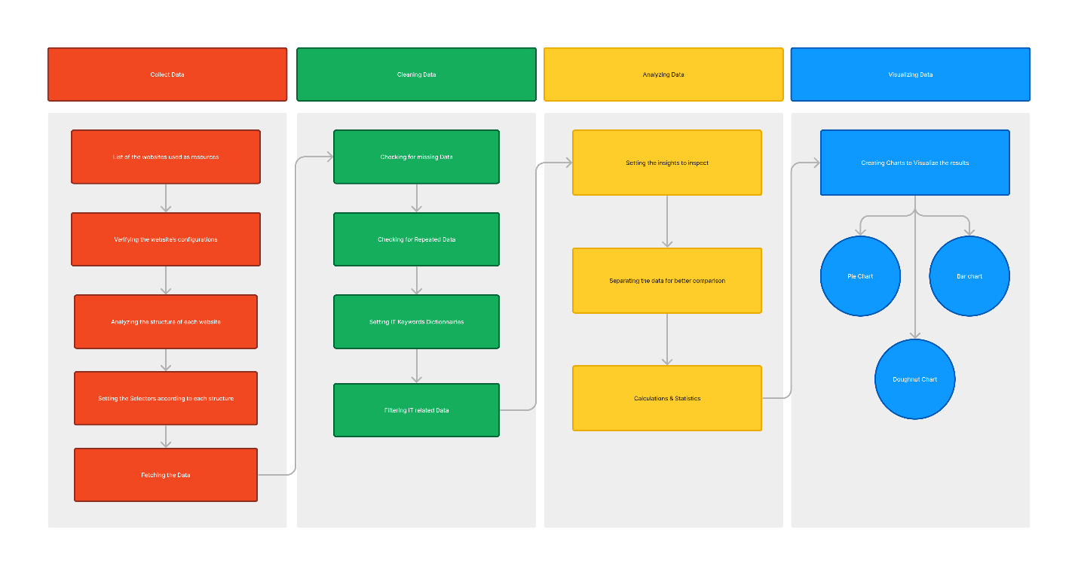

Figure 5: Flowchart Workflow Diagram

## Collecting Data

In this phase, we focus on gathering the raw data that will form the basis of our analysis. Effective data collection is crucial as it directly impacts the quality and reliability of the subsequent analysis and insights.

To ensure a comprehensive and representative dataset, multiple reliable sources are selected for extracting job listings. These sources include popular job listing websites, industry-specific portals, and professional networking platforms. By leveraging diverse sources, we aim to capture a wide range of job offers, covering various roles, technologies, and regions.

### TunisieTravail

TunisieTravail is another prominent job portal in Tunisia, dedicated to connecting job seekers with employers. The platform offers a wide range of job listings and provides valuable resources for career development.

Figure 6: TunisieTravail logo

Figure 7: TunisieTravail jobs listing structure

**Keynotes**

* **Extensive Job Listings:** TunisieTravail features extensive job listings (1 - 963 Pages) across various industries, including IT, administration, sales, and more. This makes it a versatile platform for job seekers with different professional backgrounds.
* **All Details Included:** each job is accompanied by a details page where all the needed information is included. Such as location, company name, contact etc. ….
* **Local Focus:** TunisieTravail focuses on the Tunisian job market, providing localized job listings and relevant opportunities for job seekers in Tunisia.

### Tanitjobs

Tanitjobs is a leading job board in Tunisia, offering a wide array of job listings across various industries and sectors. Established as a prominent platform for both job seekers and employers, it provides a comprehensive database of job opportunities, making it a go-to resource for employment in Tunisia.

Figure 8: Tanitjobs logo

Figure 9: Tanitjobs jobs listing structure

**Keynotes**

* **Wide Range of Job Listings:** Tanitjobs hosts a diverse array of job listings (1-214 Pages), covering sectors such as IT, healthcare, engineering, finance, and more. This diversity ensures that job seekers from various fields can find relevant opportunities.
* **Very Active Job Listing:** The platform is always updated with new jobs daily from multiple different companies. Which ensures that users have access to the latest job opportunities.
* **Advanced Search Filters:** Tanitjobs offers advanced search filters that allow users to narrow down job listings based on criteria such as location, industry, experience level, and job type.

### Keejob

Keejob is a respectable job board in Tunisia, known for its great job listings and user-friendly platform. Facilitating efficient job searches and recruitment processes.

Figure 10: Keejob logo

Figure 11: Keejob jobs listing structure

**Keynotes**

* **Vast Job Listings:** Keejob offers a vast array of job listings (1-83 Pages), covering numerous industries and job roles. This variety ensures that users can find opportunities that match their skills and career aspirations.
* **Simple Structure:** The platform uses a very minimalistic and well-presented listing which makes it much easier to collect data from.

### Paylab

Paylab is an international salary survey platform that collects information on the incomes and bonuses of employees in various positions. Paylab uses a unique methodology for collecting data with a three-phase control and over ten years’ experience. Visitors to the Paylab website or partner sites in their country can easily and anonymously complete an online questionnaire on their salary and compare their income with the national average for that position. The system always uses current data for the last 12 months. The independent salary analyses are then used by companies for the appropriate internal setting of salary levels for individual work positions.

Figure 12: Paylab logo

Figure 13: Paylab salaries data

**Keynotes**

* In Tunisia, job postings often do not include salary details, making it challenging to gauge the remuneration for various positions. To address this, we fetch salary data from Paylab, a trusted resource for compensation insights.

## Data Extraction

### Legal measurements

During our data extraction process, we strictly adhered to the directives specified in the robots.txt files of each website. The screenshots below show the robots.txt files for three of the websites used in this project: tunisietravail.net, keejob.com, and tanitjobs.com. These files were carefully reviewed to ensure compliance with the website’s rules regarding data scraping.

By respecting the robots.txt files, we ensured ethical data extraction, minimized the risk of legal issues, and maintained the integrity and reliability of the data collected. This approach reflects our commitment to ethical standards and responsible data practices.

Figure 14: Robots file for each website

### Data fetching

The data extraction process involves creating a web scraper tailored to the structure of each target website. The figure below demonstrates this process, highlighting the steps taken to parse and extract relevant job information from a website's HTML content.

Figure 15: Creating a web scraper for each source based on their structure

Before writing the web scraper, it is essential to understand the HTML structure of the target website. This includes identifying the tags and classes that contain the desired data. As shown in the left side of the figure, we inspect the website's HTML to locate the elements containing job titles, descriptions, company names, job locations, and posted dates.

Once the structure is understood, we develop a web scraper using Python and libraries such as BeautifulSoup and Pandas. The code snippet on the right side of the figure illustrates the implementation. Key steps in the web scraper include:

* **Initializing lists to store data:** We start by initializing empty lists to store job titles, descriptions, company names, locations, and posted dates.
* **Iterating through job elements:** We iterate through the elements containing job postings. For each job, we extract relevant information using the find method, specifying the tag and class name identified during the inspection.
* **Extracting job information:** We extract the job title, description, company name, location, and posted date from the HTML elements. The extracted data is then appended to the respective lists.
* **Creating a DataFrame:** After extracting the data, we create a Pandas DataFrame to organize the information into a structured format. This DataFrame will be used for further data processing and analysis.

By following this systematic approach to data extraction, we ensure accurate and efficient scraping of job-related information from multiple websites. This process is crucial for gathering the necessary data to analyze job market trends and provide valuable insights for individuals pursuing a career in the IT field.

Figure 16: Output sample of the data fetching process

## Cleaning & Filtering Data

The data cleaning process is crucial to ensure the accuracy and reliability of the dataset. This step involves addressing missing data, identifying unique job postings, and filtering the dataset to focus on IT-related jobs.

Since the resources chosen for this project are professional and well known, most of the data collected was mostly complete and well organized.

* **Identify missing values:** Use methods to detect any missing values within the dataset. This could be done by checking for null or empty fields in the data columns.
* **Remove duplicate entries:** Use methods to detect and remove duplicate job postings based on key fields like job title, company name, and job location.
* **Setting IT keywords dictionaries:** Create dictionaries of keywords related to IT job titles, skills, and technologies. This helps in identifying and filtering the relevant jobs from the dataset.

Figure 17: Keywords dictionaries

* **Applying Filters:** Apply these keyword dictionaries to the dataset to extract job postings that match the criteria for IT-related jobs. This ensures that the dataset is focused on the intended domain of study

Figure 18: Output sample of filtering data to IT related data

## Data Analysis

In this section, we delve into the analysis of the cleaned and filtered data to extract meaningful insights. The objective is to understand the dynamics of the IT job market, including its share within the broader job market, trends in job postings, and other key metrics. By analyzing this data, we aim to provide valuable information for job seekers, employers, and industry analysts.

### IT jobs market share

One of the primary focuses of our analysis is to determine the proportion of IT jobs in the overall job market. According to our data, IT jobs account for 37.31% of the total job market between March 2024 and June 2024. This significant percentage highlights the demand for IT professionals during this period.

Figure 19: IT jobs growth in the job market represented by a line chart

**Keynotes**

* As shown in the growth figure we notice that IT jobs are keeping up with the total number of jobs throughout March, April and May. But then we find a huge difference between them in June which could be explained by the seasonal summer job offers.

### IT Jobs locations

Our analysis of the geographical distribution of IT jobs reveals a significant concentration in the capital city, Tunis. This is followed by Sousse, which holds the second place in terms of IT job postings. The data indicates that IT jobs are predominantly located in the Sahel region, which is known for being one of the most developed areas in the country.

Figure 20: IT jobs locations in Tunisia represented by a horizontal bar chart

**Keynotes**

* There is a high concentration of IT jobs in Tunis, the capital.
* Sousse follows as the second leading city for IT job opportunities.

A noticeable concentration of IT jobs is observed in the Sahel region, reflecting its development and economic activity.

### IT Domains in demand

In this section, we examine the various IT domains currently in demand within the job market. By analyzing job postings, we aim to identify which areas of IT are experiencing the highest demand and which are less represented. This insight can help understand market trends and guide career choices for IT professionals.

Figure 21: IT Domains distribution represented by a doughnut chart

**Keynotes**

* It seems that the classic software and FullStack developer are the most in demand.   
  However, Artificial Intelligence and VR/XR and game development are almost nonexistent. But that doesn’t mean that there aren’t companies investing in these domains. It’s just that the market is not active in them.

Table 1: The percentage of each IT domain in the IT job market

|  |  |  |
| --- | --- | --- |
| Rank | Domain | Percentage |
| 1 | Software Development | 21.32% |
| 2 | FullStack Development | 11.67% |
| 3 | IT Support | 11.16% |
| 4 | Web Development | 10.15% |
| 5 | Network Administration | 9.64% |
| 6 | Cybersecurity | 5.07% |
| 7 | DevOps | 4.06% |
| 8 | Project Manager | 4.06% |
| 9 | UI/UX Designer | 4.06% |
| 10 | Data Science/Analyst | 3.55% |
| 11 | Internet of Things | 3.55% |
| 12 | Database Administration | 3.55% |
| 13 | QA Tester | 3.04% |
| 14 | Mobile Development | 2.53% |
| 15 | Digital Marketing | 1.01% |
| 16 | VR/XR & Game Development | 1.01% |
| 17 | Artificial Intelligence | 0.50% |

### IT Technologies in demand

This section focuses on identifying the specific technologies that are currently in high demand within the IT job market. By examining the technologies mentioned in job postings, we can pinpoint which tools, languages, and platforms employers are seeking the most. This information is valuable for IT professionals looking to align their skills with market needs.

Figure 22: Trending technologies in the IT job market

**Keynotes**

* The most technologies that are in demand seem to be web related
* Some of the old technologies are still holding the top spots over the new technologies

Table 2: Percentage of each technology in the IT market

|  |  |  |
| --- | --- | --- |
| Rank | Technology | Percentage |
| 1 | Java | 15.78% |
| 2 | PHP | 15.78% |
| 3 | React | 10.52% |
| 4 | Angular | 10.52% |
| 5 | .Net | 10.52% |
| 6 | SpingBoot | 10.52% |
| 7 | Python | 10.52% |
| 8 | SQL | 7.89% |
| 9 | Flutter | 2.63% |
| 10 | Azure | 2.63% |
| 11 | Git | 2.63% |

### IT Salaries

Using the data collected from the Paylab platform to compare the minimum and maximum salaries of the IT Employees in Tunisia

Figure 23: IT Salaries in the IT job market

**Keynotes**

* One of the most important keynotes that we notice from the chart is that there is a visible difference between the minimum and the maximum salary. Which could be an indication to as to how important the experience role plays in this domain. The more skilled and knowledgeable a person is in a specific domain the more companies are willing to pay to secure a well-established employee in their field of profession.

## Conclusion

In this chapter, we conducted a comprehensive analysis of the IT job market, focusing on key aspects such as job market share, geographical distribution, domains in demand, and technologies in demand. Our findings reveal that IT jobs constitute a significant portion of the overall job market, with a noticeable concentration in major urban centers like Tunis and Sousse. The data underscores the ongoing demand for software development and full-stack development roles, while emerging fields like AI and VR/XR remain underrepresented. Furthermore, the analysis of technologies highlights the dominance of Java and PHP, alongside a robust presence of frameworks and tools like React, Angular, .Net, SpringBoot, Python, and SQL. This chapter provides valuable insights for job seekers and industry stakeholders, emphasizing the critical areas of focus to align with market demands and opportunities.

# Chapter 3: Realization and Implementation

## Introduction

In this chapter, we delve into the practical execution of our findings and insights into the IT jobs market in Tunisia. The successful realization of this project relied on leveraging various cutting-edge technologies and platforms to gather, analyze, and present comprehensive data. Key technologies such as Python for data gathering and analysis, React for dynamic user interface development, and GitHub for version control and collaboration played pivotal roles in our methodology. Additionally, the culmination of our efforts is encapsulated in the creation of a dedicated website, serving as a centralized hub for accessing our research findings and interactive data visualizations. This chapter outlines the journey from conceptualization to execution, highlighting the technological foundations and practical steps undertaken to deliver a robust and user-centric platform for exploring Tunisia's evolving IT job landscape.

## Technologies used



Figure 24: Python logo

**Python version 3.12.0**

Python is a versatile, high-level programming language emphasizing simplicity and readability, suitable for a wide range of applications from web development to scientific computing.

**Used Libraries**

* Beautiful Soup4 4.12.3

Beautiful Soup4 is a powerful library for parsing HTML and XML documents, helping extract data from web pages. It works with different parsers to provide idiomatic ways of navigating, searching, and modifying the parse tree.

* Matplotlib 3.8.4

Matplotlib is a comprehensive library for creating static, animated, and interactive visualizations in Python. It integrates well with other libraries and tools, making it a staple for data visualization.

* Numpy 1.26.4

Numpy is the fundamental package for scientific computing in Python, providing support for arrays, matrices, and a collection of mathematical functions. It is essential for numerical computation and forms the base for other scientific libraries.

* Openpyxl 3.1.2

Openpyxl is a library for reading and writing Excel 2010 xlsx/xlsm/xltx/xltm files. It allows you to create, modify, and analyze Excel workbooks, making it ideal for data analysis and reporting.

* Pandas 2.2.1

Pandas is a powerful data manipulation and analysis library that provides data structures like DataFrames and Series. It is widely used for data cleaning, transformation, and analysis, offering a rich set of functions for handling structured data.

* Requests 2.32.3

Requests is a simple and elegant HTTP library for Python, built for human beings. It allows you to send HTTP/1.1 requests with ease, handling URL connections, sending data, and receiving responses in various formats.

* Scikit-learn 1.4.1

Scikit-learn is a robust machine learning library that offers simple and efficient tools for data mining and data analysis. It features various classification, regression, and clustering algorithms and is designed to interoperate with other scientific and numerical libraries like Numpy and Scipy.

* Scipy 1.13.0

Scipy is a library used for scientific and technical computing, building on the capabilities of Numpy. It includes modules for optimization, integration, interpolation, eigenvalue problems, and other advanced computations.

* Seaborn 0.13.2

Seaborn is a statistical data visualization library based on Matplotlib, providing a high-level interface for drawing attractive and informative statistical graphics. It simplifies complex visualizations and integrates well with Pandas data structures.

* Dateparser 1.2.0

Dateparser is a library designed to parse dates from natural language strings into Python datetime objects. It supports a wide range of date formats and locales, making it useful for international date parsing tasks.



Figure 25: React logo

**React JS version 18.2.0**

React.js is a JavaScript library for building user interfaces, known for its component-based architecture and efficient rendering. It's widely used for creating interactive web applications with reusable UI components.

**Used Libraries**

* Bootstrap 4.6.1

Bootstrap is a popular front-end framework for developing responsive and mobile-first websites, providing a wide range of pre-styled components and utilities. It ensures consistent design and ease of use across different browsers and devices.

* Chart.js 3.9.1

Chart.js is a simple yet flexible JavaScript charting library for designers and developers, enabling the creation of beautiful, interactive charts. It supports a variety of chart types and is highly customizable.

* Xlsx 0.18.5

Xlsx is a library for reading and writing Excel files in JavaScript, allowing easy manipulation of spreadsheet data within web applications. It supports various Excel formats and provides robust functionality for data processing.



Figure 26: Github Desktop logo

**GitHub Desktop version 3.4.1**

GitHub Desktop is a user-friendly application for managing Git repositories on your local machine, simplifying version control and collaboration. It integrates seamlessly with GitHub, providing a graphical interface for Git operations.



Figure 27: Visual Studio Code logo

**Visual Studio Code version 1.90.2**

Visual Studio Code (VS Code) is a versatile, open-source code editor developed by Microsoft, featuring support for debugging, version control, and a rich extension ecosystem. It is widely used for its speed, customization, and comprehensive development tools.

## Website implementation

Figure 28: Dashboard 1

Figure 29: Dashboard 2

Figures 28 and 29 showcase the analytical dashboard for our project. This dashboard includes a variety of charts that present different data sets in a clear and straightforward manner, making them easy to understand. The inclusion of real-time interactive charts is a key feature, providing better insights and enhancing the overall analysis experience.

Figure 30: Real-time interactive chart

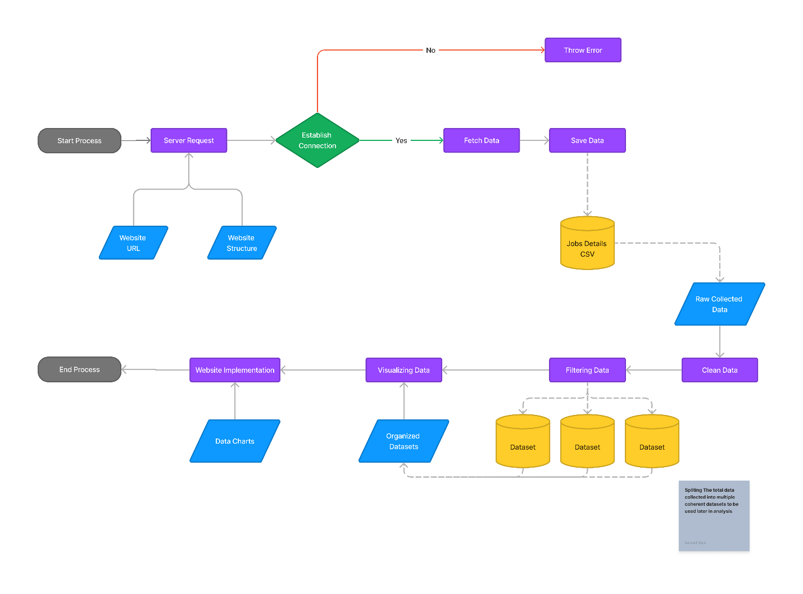

Figure 31: System flowchart

The system flowchart depicted in Figure 31 offers a comprehensive overview of the entire system's functionality. It illustrates the sequential flow of data throughout our project, clearly showing how information moves from one process to another.

## Conclusion

This chapter detailed the practical execution of our project, highlighting the use of advanced technologies and systematic methodologies to analyze the IT jobs market in Tunisia. By combining powerful tools for data processing and front-end development, we successfully created a comprehensive and interactive platform. This integration underscores our effective approach to delivering a robust solution for exploring the IT job landscape.

# General Conclusion

The culmination of this project marks a significant proof of concept, demonstrating the feasibility and potential impact of leveraging advanced technologies to analyze Tunisia's IT job market. This endeavor has showcased not only our capability to gather and analyze data effectively but also the adaptability and scalability of the platform we've created.

One of the most compelling aspects of our project lies in its expandability and flexibility. We open the door to new discoveries within the data, potentially uncovering insights that were previously inaccessible. Furthermore, establishing partnerships to access larger databases could enrich our findings and extend the platform's reach and utility.

Ultimately, we envision this platform evolving into a cornerstone resource for IT professionals and students alike. By providing comprehensive insights into the dynamics of Tunisia's IT job landscape, we aim to foster a deeper understanding that informs career decisions, educational pursuits, and strategic industry initiatives. Through continuous enhancement and collaboration, this project has the potential to not only inform but also shape the future of IT in Tunisia and beyond.

Nonetheless, we could expand more on this project with the following steps:

* Forming collaborations with IT jobs online posting site to access a much larger database
* Implementing a custom analysis feature on the website

# Netography

[1] - <https://anastasiadanilov.de/wp-content/uploads/2021/07/Firpo-et-al.-2021.pdf>

[2] - <https://himalayas.app/companies/himalayas>